**DATA FLOW DIAGRAM & USER STORIES**

|  |  |
| --- | --- |
| Date | 22 October 2022 |
| Team ID | PNT2022TMID51213 |
| Project Name | Ai based discourse for banking industry |
| Maximum Marks | 4 Marks |

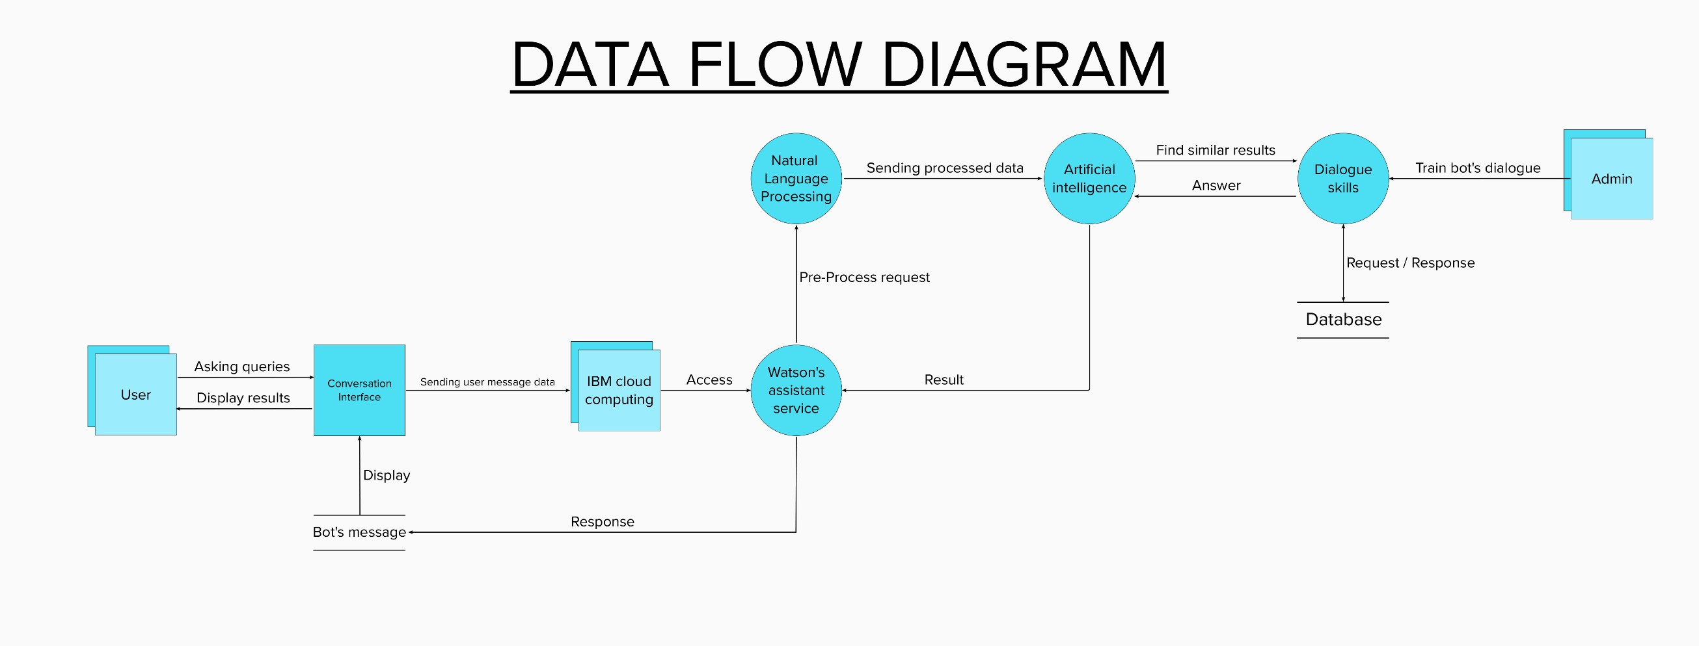

**User Stories**

|  |  |  |  |  |  |  |
| --- | --- | --- | --- | --- | --- | --- |
| **User Type** | **Functional**  **Requirement (Epic)** | **User Story Number** | **User Story / Task** | **Acceptance criteria** | **Priority** | **Release** |
| Customer (Mobile user) | Registration | USN-1 | As a user, I can register for the application by entering my email, password, and confirming my password. | I can access my account / dashboard | High | Sprint-1 |
|  |  | USN-2 | As a user, I will receive confirmation email once I have registered for the application | I can receive confirmation email & click confirm | High | Sprint-1 |
|  |  | USN-3 | As a user, I can register for the application through Facebook | I can register & access the dashboard with Facebook Login | Low | Sprint-2 |
|  |  | USN-4 | As a user, I can register for the application through Gmail | I can register & access the dashboard with Gmail Login | Medium | Sprint-1 |
|  | Login | USN-5 | As a user, I can log into the application by entering email & password | I can access my account / dashboard by Login | High | Sprint-1 |
|  | Dashboard | USN-6 | As a user, I can access the chatbot in the home page or dashboard | I can access my dashboard | High | Sprint-2 |
| Customer (Web  user) | Access | USN-7 | As a user, I can ask queries to virtual assistant | I can question the virtual assistance | High | Sprint-1 |
| Customer Care Executive | Clarification | USN-8 | As a user care executive, I will provide clarification for any questions that the chatbot  cannot answer | I can clarify questions that chatbots can't answer | Medium | Sprint-3 |
| Administrator | Moderation | USN-9 | As an admin, I can add an inquiry and its appropriate response to the chatbot | I can add an inquiry and answers to the chatbot | High | Sprint-3 |
|  |  | USN-10 | As an admin, I will moderate chatbot responses | I can moderate chatbot responses | Medium | Sprint-4 |
|  |  | USN-11 | As an admin, I will update the chatbot with new questions and responses | I can add new inquiries and responses to the chatbot | Medium | Sprint-4 |
|  |  | USN-12 | As an admin, I will maintain the chatbot's behaviour | I can maintain the chatbot's actions | High | Sprint-4 |